**Edwest Examination, 2016**

**Question/Answer Booklet**

BIOLOGICAL SCIENCES - ATAR

**Unit 3 & 4**

**Section One: Multiple-choice 30% (30 Marks)**

|  |  |
| --- | --- |
| 1 | c |
| 2 | b |
| 3 | d |
| 4 | a |
| 5 | a |
| 6 | c |
| 7 | a |
| 8 | b |
| 9 | d |
| 10 | b |
| 11 | b |
| 12 | a |
| 13 | b |
| 14 | d |
| 15 | c |
| 16 | b |
| 17 | d |
| 18 | b |
| 19 | a |
| 20 | d |
| 21 | a |
| 22 | a |
| 23 | c |
| 24 | c |
| 25 | d |
| 26 | d |
| 27 | c |
| 28 | c |
| 29 | d |
| 30 | a |

End of Section One

**Section Two: Short answer 50% (100 Marks)**

**Question 31 (15 marks)**

(a) The TRY gene codes for the production of the protein enzyme tyrosinase in melanocytes. State the two main steps in protein production. (2 marks)

|  |  |
| --- | --- |
| Description | Marks |
| 1. Transcription | 1 |
| 2. Translation | 1 |
| Total | 2 |

(b) Describe the formation of mRNA from the DNA template. (4 marks)

|  |  |
| --- | --- |
| Description | Marks |
| * mRNA is produced from the DNA template. * The sense strand is the DNA that has the same base sequence as the mRNA * The anti-sense strand is the coding strand. This forms the template for the mRNA stand to form. * RNA polymerase; (polymerase number is not required) * binds to a promoter on the DNA; * unwinding the DNA strands; * binding nucleoside triphosphates; * to the antisense strand of DNA; * as it moves along in a 5'→3' direction; * using complementary pairing/A-U and C-G; * until a terminator signal is reached (in prokaryotes); * RNA detaches from the template and DNA rewinds; | 1 - 4 |
| Total | 4 |

(c) The image below shows a structure found in cells. Briefly discuss its role in the second step of protein synthesis. (3 marks)

|  |  |
| --- | --- |
| Description | Marks |
| * tRNAs transfer or carry amino acids to ribosomes. * The tRNA molecule has three nucleotide bases, called the anticodon, and an amino acid binding site. * tRNA exist as free-floating molecules within the cytoplasm. * The type of amino acid picked up by RNA is related to the sequence of the anticodon. * The tRNA molecules contain an anticodon, which is complementary to the codon of the mRNA The tRNA molecules bring these amino acids to the ribosome where they are bonded together, forming a long chain of amino acids in a specific sequence. | 1 - 3 |
| Total | 3 |

(d) Referring to the temperature sensitive enzyme tyrosinase, provide a scientific explanation for the colouration patterns observed in Siamese cats. (3 marks)

|  |  |
| --- | --- |
| Description | Marks |
| * Increasing the temperature decreases the activity of the tyrosinase, so less melanin is produced. * Certain body parts of the cat, face, ears, legs and tail are cooler because they have * a larger surface area to volume ratio so there is greater heat loss from these areas. * The cooler body parts of the cat have more melanin and the warmer parts torso has less melanin. | 1 - 3 |
| Total | 3 |

(e) Describe how counter-current heat exchange mechanisms are used by ectotherms that live in cold environments to reduce heat loss. (3 marks)

|  |  |
| --- | --- |
| Description | Marks |
| * Blood travelling in the arteries to an area of the body exposed to cold conditions * such as extremities warms the blood returning to the body in the adjacent veins. * The outgoing blood to the extremity is cooled in the process but not enough to affect cell activities. * Because the temperature gradient between the area and the surroundings is reduced, heat loss is minimized. | 1 - 3 |
| Total | 3 |

**Question 32 (10 marks)**

(a) Differentiate between endothermic and ectothermic animals. (2 marks)

|  |  |
| --- | --- |
| Description | Marks |
| Endotherm: an animal that generates heat by metabolic activity within its body; for example mammals, birds, tuna. | 1 |
| Ectotherm: an animal that depends on absorbing heat from external heat  sources;  For example, fish, reptiles. | 1 |
| Total | 2 |

(b) Calculate the percentage of marsupials that are heterothermic. (2 marks)

|  |  |
| --- | --- |
| Description | Marks |
| Percentage of heterothermic marsupials = $\frac{68}{159} × \frac{100}{1} =42.8\%$ | 1 - 2 |
| Total | 2 |

(c) Which group of Australian mammals has the highest percentage of heterotherms? (1 mark)

|  |  |
| --- | --- |
| Description | Marks |
| bats |  |
| Total | 2 |

(d) Explain how torpor helps to reduce the energy needs of the animals. (2 mark)

|  |  |
| --- | --- |
| Description | Marks |
| Lower body temperature during torpor means the animals will need less food energy for respiration. | 1 |
| It the animal does not need to maintain a high body temperature then they do  not need to maintain a high metabolic rate. | 1 |
| Total | 2 |

(e) Discuss how torpor helps to improve the survival rate of Australian animals. (3 marks)

|  |  |
| --- | --- |
| Description | Marks |
| * Animals who do not have torpor must forage long and frequently to meet large energetic demands and thus are more vulnerable to predation by introduced foxes and cats. * Animals who have torpor can avoid adverse environmental conditions such as drought (water limitation) and a lack of food after fire | 1 - 3 |
| Total | 3 |

**Question 33 (15 marks)**

(a)Define the term ‘selection pressure’ and, based on the information provided, give an example of a

selection pressure on woolly mammoths. (2 marks)



ii.Suggest how it could be possible for *M. primigenius* to have arisen so recently (0.2 mya) yet now

be extinct, while the Asiatic elephant, *E. maximus*, has been present for over 6 million years.

(2 marks)

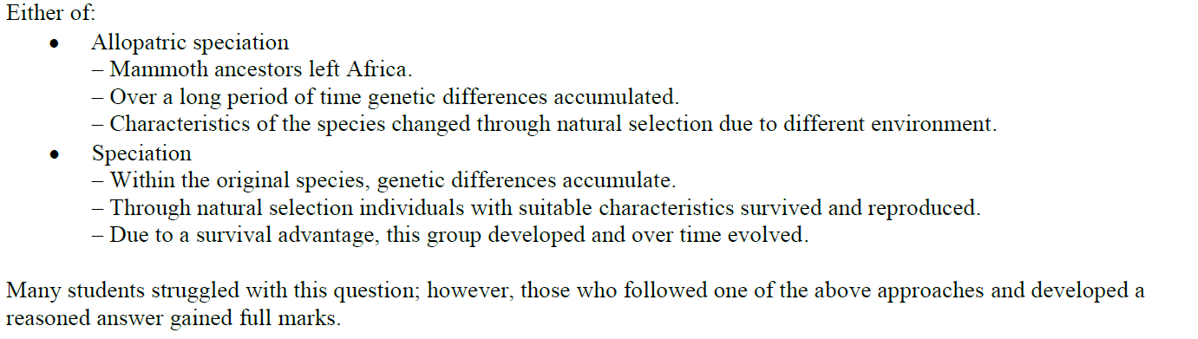

It has been suggested that elephant-like ancestors of the woolly mammoth left Africa 3.5 million years

ago (mya) and lived in Central Europe. The chart below shows a summarised phylogenetic tree based on mitochondrial and chromosomal DNA from fossils and living elephants.

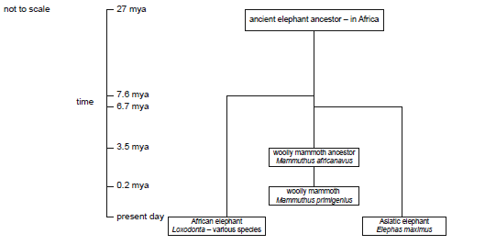

(b) Explain how the woolly mammoth *M. primigenius* probably arose from the woolly mammoth

ancestor *M. africanavus. (*3 marks)

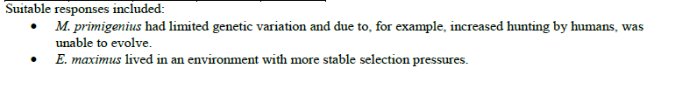

(c) A small amount of well-preserved DNA was extracted from a frozen woolly mammoth fossil. Explain how scientists could firstly increase the amount of DNA available for study in the lab, and how DNA hybridization could be used to compare the DNA of the two elephants. (8 marks)

* **Small amount of DNA is amplified using PCR**
  + **Denature**
  + **Anneal**
  + **Extend**
* **DNA from two species is heated, causing the DNA to denature**
* **It is cooled forming hybrid DNA**
* **Heat is used to separate the hybrid strands**
* **The amount of heat required to separate indicates the degree of similarity**
* **The more similar the hybrid strands, the more heat required to separate**
* **A difference of 2oC, indicated 2% of nucleotides do not pair**

**Question 34 (20 marks)**

(a) Identify the two mechanisms of transmission of the Zika virus. (2 marks)

|  |  |
| --- | --- |
| Description | Marks |
| 1. Vector – mosquito *Aedes* | 1 |
| 2. Sexual transmission | 1 |
| Total | 2 |

(b) Explain why the term ‘outbreak’ is used regarding the Zika virus in Brazil. (1 mark)

|  |  |
| --- | --- |
| Description | Marks |
| There has been a sudden rise in the incidence of a disease. |  |
| Total | 1 |

(c) Why is the Zika virus referred to as a contagious pathogen? (2 marks)

|  |  |
| --- | --- |
| Description | Marks |
| It is an infectious diseases caused by pathogenic microorganisms (a virus); | 1 |
| the diseases can be spread, directly or indirectly, from one person to another. | 1 |
| Total | 2 |

(d) What advice would you give a person travelling to Rio in August to help reduce their risk of contracting Zika? (4 marks)

|  |  |
| --- | --- |
| Description | Marks |
| * Keep mosquito’s out of the accommodation in which you are staying * Wear long sleeves and long pants to prevent mosquito bites. * Use anti mosquito sprays. * Do not have unprotected sex. | 1 - 4 |
| Total | 4 |

(e) Explain why viruses are said to be obligate parasites. (2 marks)

|  |  |
| --- | --- |
| Description | Marks |
| Viruses lack metabolic machinery to generate energy, to synthesize proteins or to reproduce; | 1 |
| Viruses depend on host cells to carry out these vital functions. | 1 |
| Total | 2 |

(f) (i) Define the term cell apoptosis (2 marks)

|  |  |
| --- | --- |
| Description | Marks |
| A form of celldeath; | 1 |
| in which a programmed sequence of events leads to the elimination of cells | 1 |
| Total | 2 |

1. Using your knowledge of the reproduction of viruses, use annotated diagrams to show how the Zika virus would infect a cell. (5 marks)

|  |  |
| --- | --- |
| Description | Marks |
| http://scienceaid.co.uk/biology/micro/images/replication.png | 1 - 5 |
| Total | 5 |

(g) List two differences between the malaria and Zika, both pathogens transmitted by mosquitos.

(2 marks)

|  |  |
| --- | --- |
| Description | Marks |
| Any 2 differences – 1 mark per difference |  |
| |  |  |  | | --- | --- | --- | |  | Malaria | Zika Virus | | Difference 1 | Caused by a Micro-organisms: Plasmodium parasites | Caused by Virus | | Difference 2 | Anopheles mosquitoes | Aedes mosquitoes | | Difference 3 | Sexual transmission not possible | Sexual transmission possible | | 1 - 2 |
| Total | 2 |

**Question 35 (20 marks)**

(a) Explain the implications of PKU being due to a germ-line mutation. (2 marks)

|  |  |
| --- | --- |
| Description | Marks |
| The mutation originally occurs in a reproductive cell. | 1 |
| The mutation therefore gets passed onto the next generation. | 1 |
| Total | 2 |

(b) What is the meaning of PKU being described as an autosomal recessive disorder?

(2 marks)

|  |  |
| --- | --- |
| Description | Marks |
| The mutation occurred on an autosomal chromosome, chromosome 12. | 1 |
| It is recessive so if the individual is not homozygous for PKU then the disorder  will not be expressed in the phenotype i.e. the person will not have the disease. | 1 |
| Total | 2 |

(c) A couple decide to have a child. Genetic tests show that they are both heterozygous for PKU. Give the genotypes of the couple and use a Punnett square to show the percentage chance that the child will have PKU. Use the symbol ‘t’ to represent the mutated gene. (5 marks)

|  |  |
| --- | --- |
| Description | Marks |
| Tt X Tt | 1 |
| |  |  |  | | --- | --- | --- | | gametes | T | t | | T | TT | Tt | | t | Tt | tt | | 2 |
| Phenotype: No PKU : PKU  3 : 1 | 1 |
| There is a 25% chance that the child will have PKU | 1 |
| Total | 5 |

(d) (i) What is a silent mutation? (1 mark)

|  |  |
| --- | --- |
| Description | Marks |
| A silent mutation occurs when a base substitution results in a codon that codes  for the same amino acid as the original codon. |  |
| Total | 1 |

(ii) Differentiate between an insertion and a deletion mutation. (2 marks)

|  |  |
| --- | --- |
| Description | Marks |
| **Insertion mutation** is the addition of one or more nucleotides at a site within the original gene sequence. | 1 |
| **A deletion mutation** is a loss of nucleotides from the site of the original gene. | 1 |
| Total | 2 |

(iii) Explain why insertion and deletion mutations are referred to a ‘frameshift’ mutations. (2 marks)

|  |  |
| --- | --- |
| Description | Marks |
| The reading frame for the corresponding amino acids has been nudged away from the original. | 1 |
| All the amino acids downstream are affected by the mutation. | 1 |
| Total | 2 |

(iv) What consequence do ‘frameshift’ mutations have on protein structure? (1 mark)

|  |  |
| --- | --- |
| Description | Marks |
| The consequence of a frameshift mutation is that the translated protein bears very little resemblance to the original protein that was coded for. |  |
| Total | 1 |

(v) Differentiate between a missense and a nonsense mutation. (2 marks)

|  |  |
| --- | --- |
| Description | Marks |
| **Missense mutation** – a single nucleotide substitution changes the amino acids. | 1 |
| **Nonsense mutation** – a single point mutation creates a new stop codon within  the original sequence. This leads to early termination of translation of the gene  sequence. | 1 |
| Total | 2 |

(e) (i) Identify which graph shows the blood serum results for a PKU sufferer. (1 mark)

|  |  |
| --- | --- |
| Description | Marks |
| Graph B |  |
| Total | 1 |

1. Give a reason for your answer to question 35 (e)(i). (2 marks)

|  |  |
| --- | --- |
| Description | Marks |
| In graph A, the amino acid levels are closer. | 1 |
| In graph B the phenylalanine levels are much higher than the tyrosine indicating  that it is not being converted into tyrosine because the relevant enzyme is  lacking. | 1 |
| Total | 2 |

**Question 36 (20 marks)**

**Question 32 (20 marks)**

The way in which pathogens are transmitted from one host to another can significantly impact how easily it can spread.

(a) Identify **two** human behaviours that can decrease the risk of contracting or spreading a contagious disease. (2 marks)

|  |  |
| --- | --- |
| **Description** | **Marks** |
| ***Two*** *points from the following*   * Not sharing needles when using illicit drugs. * Using appropriate protection during sexual intercourse. * Washing hands after using the toilet and before food preparation. * Staying quarantined when ill. | 1  1  1  1 |
| **TOTAL** | **2** |

(b) Why can a pathogen, showing latent infection, have a high degree of infectivity? (2 marks)

|  |  |
| --- | --- |
| **Description** | **Marks** |
| The pathogen lives within the host for a long period with causing symptoms so the person does not know they are sick/contagious. | 1 |
| This allows the pathogen to reach other hosts over a longer period of time and infect a greater number of people. | 1 |
| **TOTAL** | **2** |

(c) Differentiate between the terms endemic, epidemic and pandemic. (3 marks)

|  |  |
| --- | --- |
| **Description** | **Marks** |
| An endemic is when a disease occurs within a population at a steady rate. | 1 |
| An epidemic occurs when the disease begins to increase in the population above what is considered normal. | 1 |
| A pandemic occurs when an epidemic spreads across many countries or continents throughout the world. | 1 |
| **TOTAL** | **3** |

The development of vaccines has enabled highly contagious diseases to be eradicated from the global population.

(d) Describe how immunisation programs have been successful in stopping the spread of virulent pathogens? (2 marks)

|  |  |
| --- | --- |
| **Description** | **Marks** |
| Reducing the rate of infection of virulent pathogens. | 1 |
| Eradicating some diseases by completely stopping spread through mass immunisation programs. | 1 |
| **TOTAL** | **2** |

(e) Explain the concept of ‘herd immunity’. (2 marks)

|  |  |
| --- | --- |
| **Description** | **Marks** |
| When a large proportion of the population are immunised so the few left unimmunised cannot sustain the disease. | 1 |
| The chance of coming into contact with an infected person is very low and the disease cannot spread. | 1 |
| **TOTAL** | **2** |

(f) Explain why herd immunity has been compromised in some communities around Australia. (2 marks)

|  |  |
| --- | --- |
| **Description** | **Marks** |
| More people are choosing NOT to have their infants/children immunised due to fear of serious illness from side effects and misinformation. | 1 |
| The growing number of non-immunised individuals weakens the ‘herd immunity’ and certain diseases can be reintroduced into a population. | 1 |
| **TOTAL** | **2** |

(g) Identify **two** adaptive characteristics of bacteria and explain how these characteristics increase their chance of survival. (4 marks)

|  |  |
| --- | --- |
| **Description** | **Marks** |
| ***Two*** *adaptations from the following*   * **Flagellum** – helps to move around increasing spread. * **Slimy bacterial capsule** – helps bacteria stick to surfaces like cells OR can also increase virulence by impeding immune response. * **Endospore formation** – make bacteria resistant to extreme conditions allowing increased rate of dispersal. | 1 – 2  1 – 2  1 – 2 |
| **TOTAL** | **4** |

(h) Outline **three** different ways in which bacteria cause disease. (3 marks)

|  |  |
| --- | --- |
| **Description** | **Marks** |
| ***Three*** *points from the following*   * Divide rapidly, damaging tissues directly. * Production of toxins that disrupt cell function. * Pathogenic parts of bacteria stimulate an overly strong and damaging immune response. * Interfering with the host’s immune system, increasing the susceptibility to infection by other pathogens. | 1  1  1  1 |
| **TOTAL** | **3** |

**End of Section 2**

**Section Three: Extended answer**

**Unit 3: Choose either Question 37 or Question 38**

**Question 37 (20 marks)**

(a) Describe the semi-conservative process of DNA replication. (10 marks)

|  |  |
| --- | --- |
| **Description** | **Marks** |
| * each (molecule formed) has one new strand and one from parent molecule; * helicase uncoils DNA; * helicase separates the two strands by breaking hydrogen bonds between bases; * RNA primase adds primer / primase adds (short) length of RNA; * DNA polymerase III binds to/starts at (RNA) primer; * DNA polymerase (III) adds nucleotides/bases in a 5’ → 3’ direction; * bases according to complementary base pairing / A–T and C–G; * (leading strand) built up continuously (towards the replication fork); * (lagging strand) built up in pieces/short lengths/Okazaki fragments; * DNA polymerase I removes RNA/primers and replaces them with DNA; * ligase seals gaps between nucleotides/fragments/makes sugar-phosphate bonds; * nucleoside triphosphates provide the energy to add nucleotides; | 1-10 |
| **Total** | **10** |

(b) One of the types of inheritance is known as sex-linked inheritance. Explain this type of inheritance, providing at least one example. (10 marks)

|  |  |
| --- | --- |
| **Description** | **Marks** |
| * sex linkage applies to genes that are located on the sex chromosomes; * these genes are considered sex-linked because their expression and inheritance patterns differ between males and females. * Colour blindness is also caused by a defective gene on the X-chromosome. * One dominant copy of the gene allows us to see red and green; * males have just one X-chromosome, which they receive from their mother; * inheriting one defective copy of the gene will render them colour blind; * females have two X-chromosomes; * to be colour blind they must inherit two defective copies, one from each parent. consequently, red-green colour blindness is much more frequent in males than in females. * Worked example: XC: normal; Xc :colour blind; there is no allele on the Y chromosome.   **Parents:** Carrier female X normal male  XCXc X XCY  **gametes:** XC or Xc and XC or Y  **F1**: 1XCXC:1XCXc: 1XCY:1Xc Y  2 normal females : 1 normal male : 1 colour-blind male | 1-10 |
| **Total** | **10** |

**Question 38 (20 marks)**

(a) Explain how comparative anatomy provides evidence of evolution

(10 marks)

* **Homologous structures**
  + **Allows comparison of similar structures**
  + **That have been modified**
  + **Shows common origins and therefore common ancestry**
  + **For example…**
* **Vestigial Structures**
  + **Are body parts that have lost all or some of their ancestral function**
  + **But are retained in reduced form**
  + **For example…**
* **Comparative embryology**
  + **Comparing embryos**
  + **Shows similarities**
  + **For example….**
  + **Demonstrating common ancestry**

(b) Discuss the differences between natural selection and sexual selection as driving mechanisms for evolution. (10 marks)

|  |  |
| --- | --- |
| **Description** | **Marks** |
| **Natural selection.**   * Influences only heritable traits; * Heritable traits that increase an individual’s chances of surviving and reproducing are more likely to be passed on to the next generation; * Organisms within a species vary, more individuals are born than survive to reproduce; Individuals best adapted to their environment are more likely to survive and reproduce; * Over time, this can lead to heritable changes that better adapt a species to its environment; * Natural selection acts on the phenotype (i.e. the appearance of an organism) and not the genotype (its genetic makeup) | 1-5 |
| **Sexual selection.**   * Refers specifically to competition for mates; * Chooses heritable traits that increase an organism’s chances of mating; * Competition within a sex for access to a mate leads to large and strong males – competition for dominance; * Specific physical or behavioural traits are selected for depending on their effectiveness in ensuring mating success – colourful male birds, courtship behaviour; * Unusual characteristics such as the enlarged pincer in the fiddler crab – attract females as they indicate stronger genes that ensure survival; * Sexual dimorphism (specific traits other than reproductive organs occurring only in one sex or being enhanced in one sex) | 1-5 |
| **Total** | **10** |

**Unit 4: Choose either Question 38 or Question 39.**

**Question 39 (20 marks)**

(a) Describe the adaptations that the leaves of the vegetation in Mallee Shrublands would have to help the plants survive the hot, dry summers. (10 marks)

|  |  |
| --- | --- |
| **Description** | **Marks** |
| Mallee plants show many adaptations to survive dry climates such as;  **Reducing the surface area of their leaves to minimise water loss;**   * Leaf adaptation includes tiny leaves, long narrow leaves, needle-shaped leaves or rolling their leaves during the hottest part of the day. When the leaf is rolled fewer stomatal grooves are exposed to the drying   **Leaves which reflect heat and light**   * Some plants have shiny leaves, with waxy cuticles that reflect heat; * Light coloured leaves, especially if they are hairy, reflect significantly more radiant heat energy; * Fine hairs also decrease the air movement close to the surface of the plant, thus reducing water loss by evaporation. * More stomata located on the under surfaces of leaves and it is on this surface that most hairs are found   **Leaves which hang vertically and edge-on to the sun;**   * This reduces the total surface area exposed to the sun   **Sclerophyllous leaves;**   * Plants have hard, leathery leaves which reduce wilting and thick waxy cuticles which reduce water loss   **Succulents**   * Plants store water in fleshy stems or leaves. | 1-10 |
| **Total** | **10** |

***(b) Explain how Australian Bat lyssavirus is transmitted from bat to human. Outline the signs of infection, possible treatments and preventative measures currently used in Australia. (10 marks)***

* Lyssavirus is usually transmitted via a bite or scratch from an infected bat or mammal. (1)
* Infection can also occur through contact with body fluids or waste. (1)
* Lyssavirus has a variable/long incubation period from weeks to months so symptoms of infection may not be obvious for some time. (1)
* First signs of disease/infection include fever, headache and fatigue. (1)
* The virus then infects the nervous system and causes paralysis, delirium, convulsions and eventually death (within a few weeks). (1)
* If a person is scratched or bitten the wound should be washed/cleaned and applied with antiseptic or antiviral medication (like ethanol or iodine). (1)
* Directly after exposure to a bite or body fluids, the vaccine can be administered due to the long incubation period of lyssavirus. Must be vaccinated before illness begins. (1)
* The vaccine/s are the same as those used for Rabies. Injected at the site of injury and other soft tissue. (Follow up injections required.) (1)
* Preventative measures are (at least **two**); no contact with bats or touching injured bats, being trained to handle bats and wearing protective garments, vaccination for lyssavirus prior to contact/handling bats. (1 – 2)

**Question 40 (20 marks)**

***(a) Describe the structure of a virus and its method of reproduction. Include a simple, labelled diagram to show the reproductive process. (10 marks)***

* Viruses are very simple and not classed as true living cells. They are non-cellular agents, sometimes referred to as obligate parasites. (1)
* They are comprised only of a protein coat and nucleic acid. (1)
* Viruses cannot reproduce or function outside a living cell. They need a host cell to carry out normal cell functions. (1)
* Viruses are very specific to the host cell or organism it can infect. (1)
* Some viruses only infect and reproduce in one type of species (variants of malaria) while others can successfully infect multiple species (swine flu). (1)
* When virus infects its preferred host, it ‘seeks out’ the specific cell it affects. The virus recognises the protein receptors on the cell membrane and bind to them. (1)
* It injects the cell with its nucleic acid, which takes over cell function. (1)
* **Simple diagram (eg., below)** of how a virus reproduces in a host cell. (1 - 3)

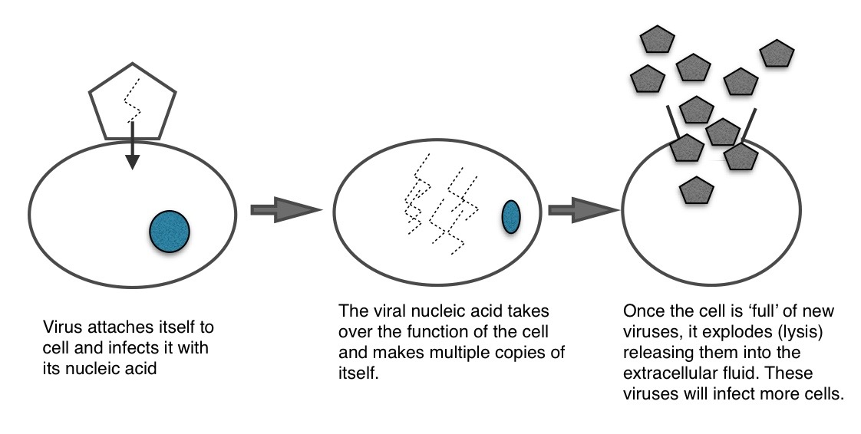

(b) Barramundi have well developed physiological mechanisms for the regulation of salt to allow them to survive in salt and freshwater. Discuss how these mechanisms adapt as the Barramundi move from fresh water into salt water. (10 marks)

|  |  |
| --- | --- |
| **Description** | **Marks** |
| When the Barramundi live in salt water, they will be osmoconformers and match  their osmolarity to the surrounding salt water:   * Gain of water and salts from drinking sea water. * They lose water by osmosis though gills and other parts of the body surface. * Small volume of urine produced. Urine is slightly less concentrated then body fluids. * Excretion of ions in urine and through the gill surface. * They balance water loss by drinking seawater and excreting salts. | 1-5 |
| When the Barramundi live in fresh water, they will be osmoregulators and regulates their body osmolarity so it remains constant regardless of the external environment.   * Actively control salt concentrations despite the salt concentrations in the environment. * Constantly take in water by osmosis from their hypoosmotic environment. * Water is gained by drinking, food and osmosis through the surface of the gills and other body parts. * They lose salts by diffusion. * Maintain water balance by excreting large amounts of dilute urine. Urine is less concentrate than the body fluids. * Salts lost by diffusion are replaced by uptake of salts across the gills. | 1-5 |
| **Total** | **10** |